Task 1 : Foundation & Environment Setup
Cybersecurity Lab Setup Report
Installation and Configuration of a Cybersecurity Lab Using Kali Linux, Metasploitable, DVWA, and Wireshark
1. Introduction
The objective of this lab is to design and configure a secure, isolated cybersecurity testing environment for practicing ethical hacking, network analysis, and vulnerability assessment. The lab consists of Kali Linux as the attacker machine, Metasploitable and DVWA as vulnerable target systems, and Wireshark for network traffic analysis. All systems are hosted within VMware to ensure a safe and controlled environment.
2. Tools and Technologies Used
Tool | Purpose
VMware Workstation | Virtualization platform
Kali Linux | Attacking and security testing OS
Metasploitable2 | Intentionally vulnerable Linux system
DVWA | Web application vulnerability testing
Wireshark | Network packet capture and analysis
3. Lab Environment Architecture
- All virtual machines are configured in a Host-Only Network
- No direct internet access between attacker and target machines
- Communication is restricted within the lab to ensure safety
- Kali Linux acts as the attacking and monitoring system
- Metasploitable and DVWA act as vulnerable targets
4. Kali Linux Setup in VMware
4.1 Installation
- Downloaded Kali Linux VMware image from the official website
- Imported the image into VMware Workstation
- Allocated system resources:
  - RAM: 4 GB
  - CPU: 2 cores
  - Storage: 40 GB
4.2 Network Configuration
- Network adapter set to Host-Only
- Verified IP address using:
- ip a
- Confirmed connectivity with target machines using:
- ping <target-ip>
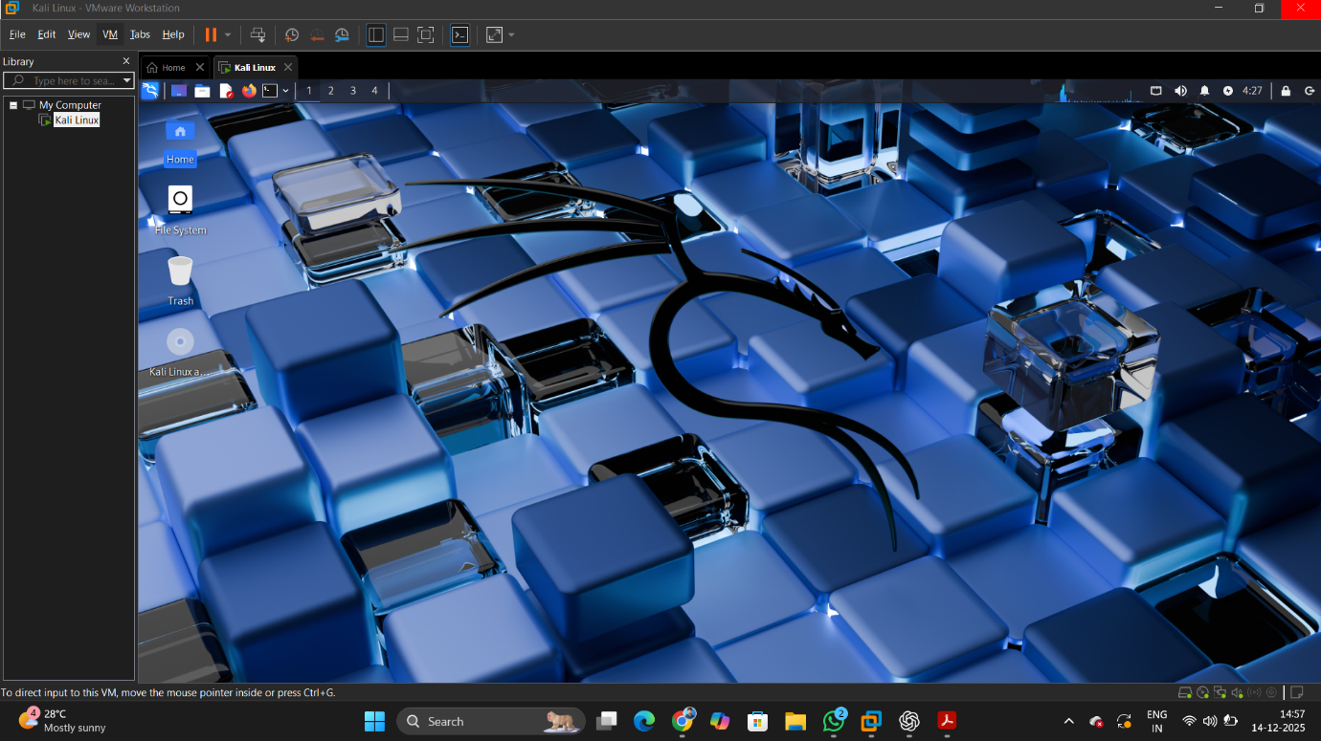
5. Metasploitable Setup
5.1 Installation
- Downloaded Metasploitable2 virtual machine
- Imported into VMware
- Configured network adapter to Host-Only
5.2 Verification
- Logged into Metasploitable using default credentials
- Verified IP address:
- ifconfig
- Confirmed reachability from Kali Linux using ping
5.3 Purpose
Metasploitable is used to:
- Practice vulnerability scanning
- Exploit misconfigured services
- Understand real-world attack vectors
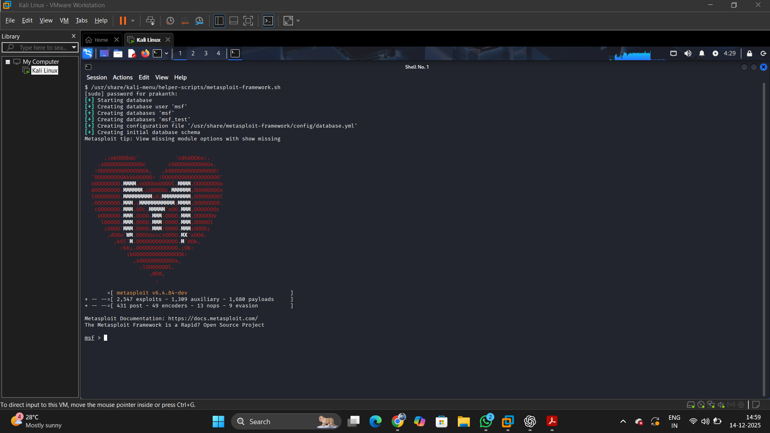
6. DVWA (Damn Vulnerable Web Application) Setup
6.1 Installation
- DVWA installed on a Linux server VM
- Apache, MySQL, and PHP configured
- DVWA security level set to low for learning purposes
6.2 Configuration
- Database initialized via DVWA setup page
- Accessed through browser:
- http://127.0.0.1/dvwa
6.3 Purpose
DVWA allows hands-on practice with:
- SQL Injection
- Cross-Site Scripting (XSS)
- Command Injection
- Authentication vulnerabilities
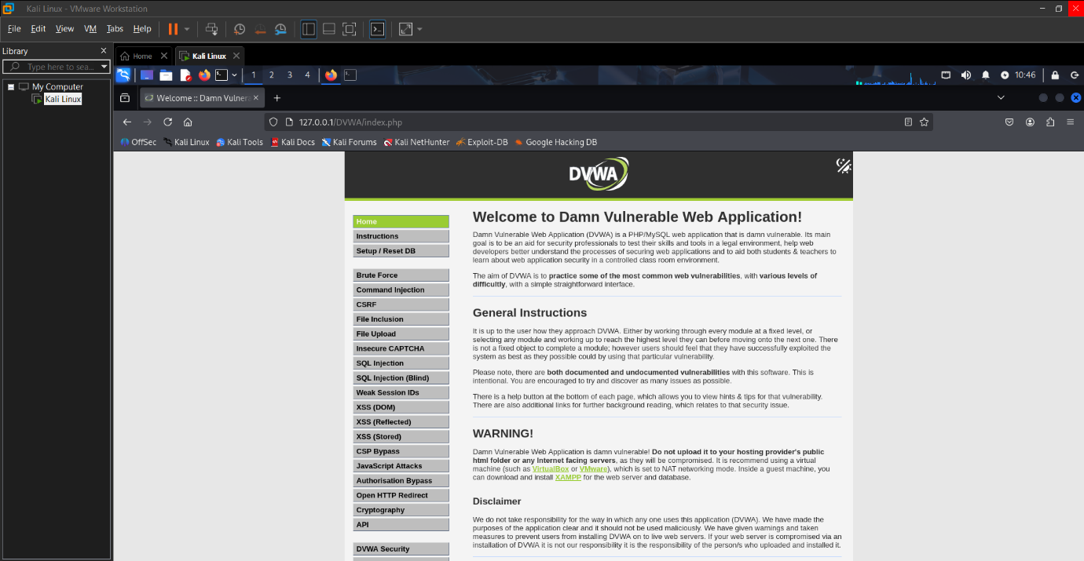
7. Wireshark Setup and Usage
7.1 Installation
- Wireshark installed on Kali Linux
- Granted capture permissions
7.2 Packet Capture
- Selected active network interface
- Captured traffic during:
  - Ping requests
  - Nmap scans
  - Web requests to DVWA

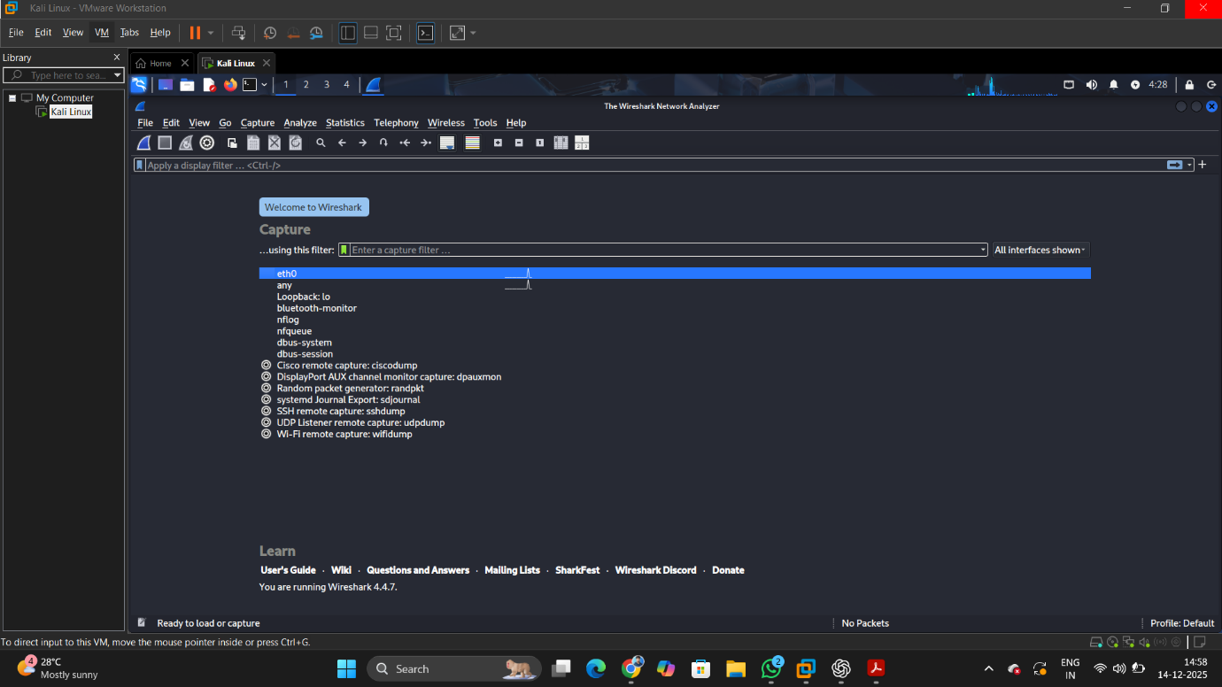
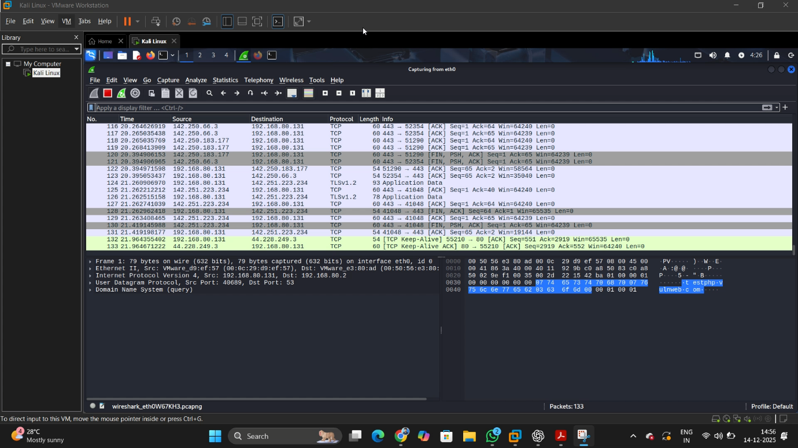
8. Lab Validation and Testing
The lab setup was validated by:
- Successful communication between Kali and targets
- Nmap scans detecting open ports
- Wireshark capturing network packets
- DVWA web attacks functioning as expected
9. Security Considerations
- All testing was conducted in an isolated host-only network
- No attacks were performed on live or public systems
- This lab is strictly for educational and ethical purposes
10. Conclusion
This lab successfully demonstrates the setup of a complete cybersecurity testing environment using VMware, Kali Linux, Metasploitable, DVWA, and Wireshark. The environment enables hands-on learning of Linux commands, networking concepts, vulnerability assessment, and ethical hacking techniques. This setup provides a strong foundation for advanced cybersecurity learning and professional development.

